Operation Manual

HM-C10 Cable Fault Pinpointer

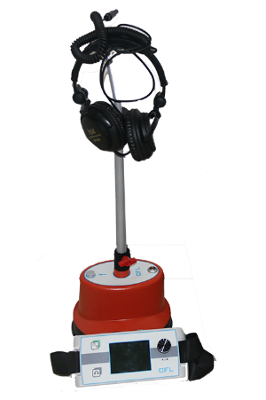

WUHAN GOLDHOME HIPOT ELECTRICAL CO.,TLD
Tel.：+86-27-84663808 Mobile.：+86-13720185294
Email：goldhome02@cablehipot.com Web.: www.cablehipot.com
Add.: No.A25-1, Huading Mould Industrial Park, Hannan, Wuhan, Hubei, China

Chapter 1. Overview
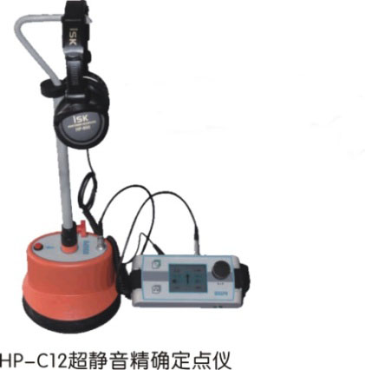
HM-C10A Cable Fault Acousto-Magnetic Accurate locater is a portable, ultra-quiet, and visualized impulse discharge receiver precise locating instrument. It is specially used in conjunction with a high-voltage impulse generator. It adopts advanced background intelligent noise reduction and sound tracking new technologies, can achieve continuous optimization, perfect sound effects, record the characteristic sound of impact discharge and compare the signal picked up on site.
When the front-end continuous impulse discharge, the impulse discharge sound of the fault point within the rough measurement distance is transmitted on the ground above the cable, and is recorded by the ground probe on the ground. The distance between the detection point and the true fault point of the cable can be obtained by the volume of the impact discharge noise.

Chapter 2. Technical characteristics
◆Ultra-quiet noise reduction processing, excellent discharge sound quality, quieter background, monitor headphones are used to quickly and reliably locate the fault point.
◆Using ultra-quiet technology and BNR intelligent background noise reduction technology, the volume of impact discharge can be adjusted.
◆ A special free-falling ground-penetrating sensor is designed, and equipped with sensor joints for soft pavement, hardened pavement and lawn.
◆ The reliable imported connectors are used to ensure the purity of the sound. The humanized design of the height-adjustable probe handle is very suitable.

Chapter 3. Technical parameters
◆ Sensor dynamic range: sound channel>104dB.
◆ Impact discharge sound amplification factor >90dB, and the upper limit of the impact discharge volume is 84dB(A).
◆ LCD display: high-brightness true color screen, 320 x 240 pixels, suitable for outdoor use.
◆ Power supply: Alkaline replaceable battery/Lithium-ion rechargeable battery, convenient for field use.
3.1. Standard configuration:
• One receiver host, model HM-C10A, including shoulder strap;
• One sensor (ground penetrating microphone);
• One height-adjustable handle with a height range of 450-750 mm;
• One earphone, sound quality;
• One signal line, which connects the receiver host to the sensor, 1.20m long;
• One hard ground probe, 18 mm long;
• One grass probe, 75 mm long;
• 6 AA alkaline batteries, model IEC R6;
• One manual.
3.2. Connection and control of the receiver host
The following figure shows the connection method and control buttons of the HM-C10A receiver host:
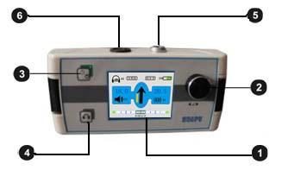
1. LCD display 2. One-key adjustment button 3. Receiver switch on(the red LED indicator flashes after press for 10 seconds)/off (after press for 3 seconds) 4. Mute on/off 5. Connect socket and sensor 6. Connect the socket and earphone.

Chapter 4. HM-C10A site installation and operation
Turn on HM-C10A and prepare the sensor.
4.1. Connect the sensor to a suitable probe
The HM-C10A sensor can be connected to two different probes. The standard configuration includes one 18mm long hard ground probe and one 75mm long grass probe. The above probes can be screwed on with threads to suit various ground covering conditions.
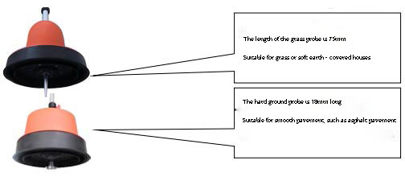
4.2. Connect the sensor to the handle
The figure below shows how to connect the adjustable handle with the sensor:
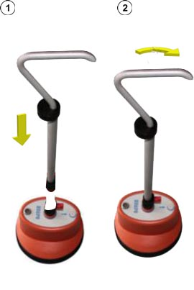
4.3. Adjust the height of the handle
The following figure shows how to adjust the height of the handle:
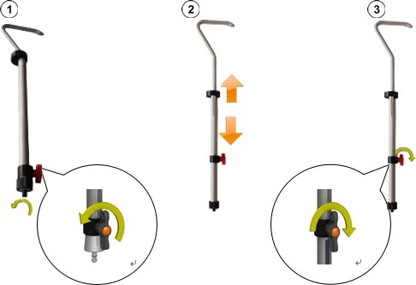
4.4. Connect the sensor and headset to the receiver host
Connect the headset to the black socket of the receiver. Please pay attention to align the white marks on the plug and socket. The plug is plug and play, please do not rotate.
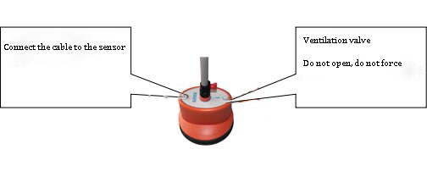
4.5 Introduction to HM-C10A receiver host
1. Turn on the receiver host
Pressing the on/off button to start/shutdown the receiver. The receiver host will be ready for use after several seconds and the measurement interface will be displayed.
2 Battery self-checking
Be sure the battery power is over 50% before using.
3. One-key knob
Please refer to the figure below for the use of one-key adjustment keys:
 | Function
 | volume adjustment
4. Display of measurement interface
When you are close to the fault point in the process of precise locating, HM-C10A displays relevant information that may be useful through the measurement interface.
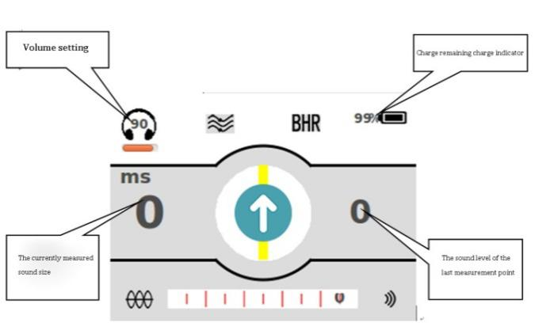

Chapter 5. Operating procedure
Please connect the high-voltage integrated impulse generator (high-voltage unit) to the faulty cable, and start to apply an appropriate impulse voltage to cause a flashover breakdown discharge at the fault point Appropriate impulse voltage refers to the model suitable for the cable under test, and the highest allowable impulse voltage will not cause damage to the cable under test. For more details on using the high-voltage impulse generator (high-voltage unit), please read the HP-G35 integrated high-voltage power supply operation manual.
5.1 Precise locating operation procedures
When you are approaching the point of failure, please follow the sequence of procedures below:
Step 1: Place the ground penetrating microphone of HM-C10A at the initial position.
Step 2: If HM-C10A cannot pick up any sound signal at this measuring point, please follow the route of the cable under test. When the HM-C10A has received the first useful shock discharge sound signal, the left side of the LCD of the HM-C10A host will automatically display the sound level at the measuring point.
If HM-C10A cannot pick up the impulse discharge sound signal through the ground penetrating microphone or earphone in a long time, you should try to accurately locate the point from the starting point in the opposite direction.
Step 3: Continue along the path of the cable under test, moving one step at a time, and adjust the position of the center axis of the cable under test if necessary. At each measuring point, please stop for several impulse discharge signals.
When you approach the cable fault point, you will hear a stronger knocking sound, and the sound level of the current measurement point displayed by HM-C10A will increase suddenly.
Step 4: Rotate the HM-C10A ground penetrating microphone 180° and approach the fault point again with a smaller step.
Step 5: Please continue to reduce the step distance, find the point where the fault sound is loudest, and locate the fault point as accurately as possible. Make a precise mark on the ground.
5.2 Switch off HM-C10A
Press on/off button for a long time to switch off.
Note: This instrument can only be operated by trained and experienced professional electricians. Keep anyone else away from this instrument.
This instrument can only be used by authorized electrical professionals. Electrical professionals refer to those who hold a high-voltage electrician license issued by the State Electricity Regulatory Commission and above qualifications, have sufficient professional knowledge, work experience, and are familiar with various Safety regulations.
Failure or damage caused by the user's private repair and disassembly is not covered by the warranty.

